Introduction
The Regional Prevention Partnerships (RPP) grants are a customized regional response to reduce alcohol and drug use among adolescents, teens, and young adults. This is a federally funded program that builds on Vermont’s success with the 2012-2015 Partnerships for Success (PFS) Grant and use of the strategic prevention framework.

RPP continues to structure prevention efforts with the strategic prevention framework to ensure prevention programs stay on track to make a positive change in meeting prevention program goals, and support an effective regional prevention network that will collectively cover the entire state. Additionally, the RPP grants address the health disparities related to substance use by Vermonters identified in these sub-populations: LGBTQ, low socioeconomic status (SES), and military families.

Goal
Successful substance use prevention among youth significantly decreases the likelihood of substance use problems and dependence in adulthood. The RPP grants are aimed at reducing the following:

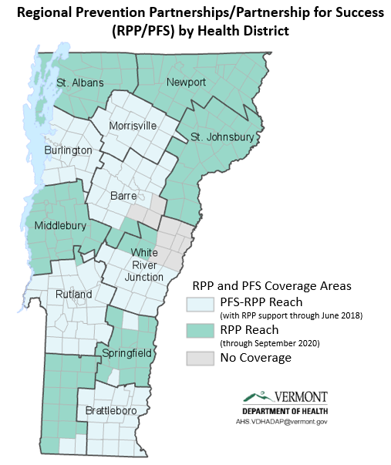
- Past 30-day alcohol use among adolescents and young adults (ages 12-20)
- Past 30-day binge drinking among adolescents and young adults (ages 12-20)
- Past 30-day marijuana use among adolescents and young adults (ages 12-25)
- Past 30-day prescription drug misuse among adolescents and young adults (ages 12-25)

Grants Program
Each Vermont Department of Health (VDH) health district received an RPP grant: Twelve RPP Lead Agencies were awarded approximately $130,000 each (totaling approximately $1,560,000) to coordinate/provide and enhance substance use prevention and early intervention services in their health district. Six of the health districts had received funding under a previous federal grant (PFS). Most of these six RPP Grantees are in process of implementing evidence-based substance use prevention activities similar to those implemented under the PFS grant.

Progress
RPP is estimated to have reached 544,054 Vermonters in FY17 through population-based interventions (e.g. policy, enforcement, education and outreach on prevention of prescription drug misuse, etc.).

Evaluation / Outcomes

Based on a comprehensive substance use prevention plan developed in partnership with the community, grantees are implementing evidence-based strategies, including but not limited to:
- Assessments & Planning
  - Complete Local Community Assessments
  - Update / Complete Regional Plan
- Local Policy Enhancements
  - Education on Possible Local Alcohol and/or Marijuana Policies/Ordinances
  - Promotion of Incorporating Health Goals in Town and Regional Plans
- Promote Best Practices with Local Alcohol Retailers
  - Support Department of Liquor Control’s (DLC) Responsible Beverage Service Trainings
  - Recognize Retailers for Passing DLC Compliance Checks
- Enhance Local DUI Enforcement
  - Sobriety Check Point
  - Party/Saturation Patrols
  - Promoting DRE and ARIDE Training
- Education / Outreach on Proper Storage & Safe Disposal of Prescription Drugs
- Regional Capacity Building
  - Media Advocacy
  - Promotion of Statewide Media Campaigns
  - Promote & Implement Cultural Competent Processes
The RPP strategy outcomes are being tracked in the Youth Risk Behavior Survey (YRBS—for students in grades 9-12) and in the Young Adult Survey (YAS—for young adults 18-25).

Selected Success Stories Reported by Grantees:

Prescription Drug Take Back Day
“Take Back Day is an actionable cause and makes the education about opiates etc. a tangible topic of concern that people can engage and act on. This is one of the reasons we have found it helpful to make the personal appearance in communities, distributing the materials and engaging conversations indicated that many people are aware of the problem and interested in disposing their unused meds.”
Local Policy Enhancements
“Windham County Planning for Prevention Primer is finally completed and printed!”
Regional Capacity Building
“[We] engage a diverse group of community stakeholders to regularly attend monthly meetings and actively participate on subcommittees. The connections forming through these committees are developing in ways that will reinforce and increase the effectiveness of prevention efforts in the county”

V. 12/2017

This value is calculated using census data for all individuals age 12 and up in the towns reached by all active population-based interventions.

